THERMAL LABEL PRINTER

**User Manual**



**Safety Warning！**



**(1)** **Caution! Sharp parts!**

The paper-cutting blade has sharp edges. Please be careful not to touch it to avoid cuts.

**(2)Attention! Hot Parts!**

**After printing is completed, do not directly touch the print head to avoid being burned by overheating. After turning off the power, wait for half an hour before touching the print head. This product is not suitable for children.**

**(3) Attention! Moving Parts!**

**Keep your body away from the moving parts and be careful**

。

**Attentions**

**(1) The printer should be installed in a stable place to avoid vibration and impact.**

**(2) Do not use and store printer in places with high temperature, high humidity or heavy pollution.**

**(3) Connect the printer's power supply to an appropriate ground socket. Avoid using the same socket as large motors or other devices that can cause voltage fluctuations in the power supply.**

**(4) Avoid water or conductive material (such as metal) entering the printer and turn off the power immediately if this happens.**

**(5) Keep the printer printing from without paper or else it will damage to the printer head and the rubbber roller.**

**(6) Please cut off the power supply if you will not use this printer for long time.**

**(7) The user shall not dismantle the printer for maintenance or modification without authorization.**

**(8) The power cord shall only be supplied with a randomly assigned power cord.**

**(9) In order to ensure the quality of printing and product life, it is recommended to use high-quality printing paper.**

**(10) When unplugging and connecting the power cord, make sure the printer power is turned off.**

**(11) The power cord plug acts as a power disconnect device and its socket is located near the device and is easily accessible.**

**(12) This product is only suitable for use in tropical climate at an altitude of 5000 meters and below.**

**Chapter 1 Product Introduction**

**1.1 Printer Appearance**



### **1.2 Printer accessories**

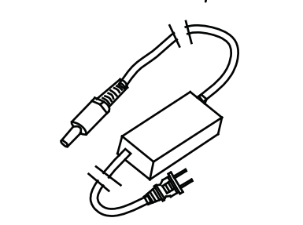 

Printer 1pcs Adapter 1pcs



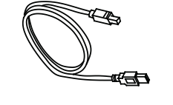

USB Cable 1pcs User Manual 1pcs

**Chapter 2 Performance Characteristics**

|  |  |
| --- | --- |
| **Printing Method** | **Thermal Printing** |
| Printing Dot Matrix | 864 dots/line |
| Resolution | 203dpi (8 dots/mm) |
| Printing Speed (Max) | 150mm/s |
| Paper Width | 20 - 112mm |
| Printing Width | 108mm |
| Supported Printing Types | English, Chinese characters, numbers, various symbols, graphics, curves, pre-stored icons, etc. |
| Barcodes | One - dimensional codes: UPC - A, UPC - E, EAN - 13, EAN - 8, ITF25, Code39, Code93, Code128, CODEBAR; Two - dimensional code (QR Code) |
| Communication Interface | USB + Bluetooth/ [Optional] |
| Adapter | DC 24V/2.5A AC100 - 240V |
| Abnormality Detection | Front paper output detection/paper shortage detection/high temperature detection/cover open detection |
| Paper Loading Method | Easy Paper Loading |
| Instruction Set | TSPL, CPCL, YAEN compatible instruction set YPL |
| Paper Cutting Method | Manual Tearing |
| Appearance Dimensions | 180.5mm * 83.4mm * 80.4mm |
| Weight | 725g |
| Working Environment | Temperature 5℃ - 45℃, humidity 20% - 90% |
| Storage Environment | Temperature - 25℃ - 55℃, humidity 20% - 93% |

**Chapter 3 Usage Method**

**3.1 Basic Function Usage**

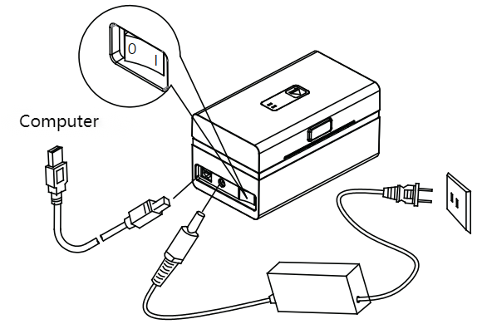

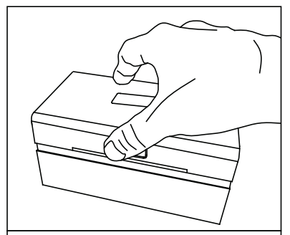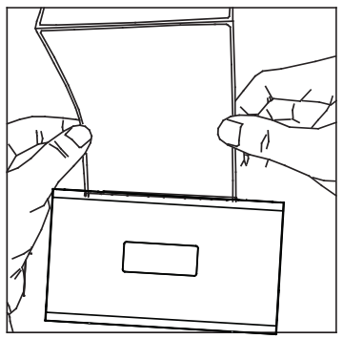

1. （2）

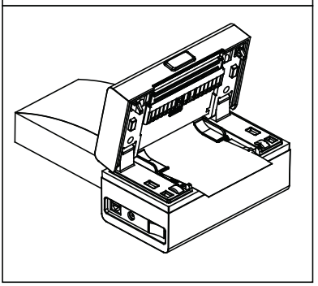 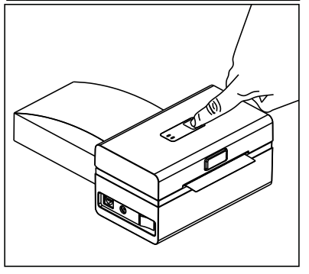  (3) (4)

**3.1 Basic Function Usage**

1. Set the printer power switch to the off (O) position.
2. Insert the adapter power plug into the printer's power socket.
3. Insert the power cord connector into the power adapter.
4. Insert the other end of the power cord into a suitable AC power socket.
5. Load the printing paper into the printer (paper can be loaded automatically when the printer is turned on).
6. Switch the power switch to the "I" position to turn on the printer.

**3.2 Self - test**

After obtaining the printer, the user can perform a self - test on the printer at any time to detect the current settings and status of the printer. The self - test method is as follows: turn on the printer (if the printer is in the off state), then press the [Button] until you hear a "beep" sound, and then release the button. The printer will print a self - test page, which contains the current status of the printer, printer settings and printing examples.

**3.3 Media Calibration**

If the label is not calibrated during the printing process, media calibration can be used to calibrate the label paper. The media calibration method is as follows: turn on the printer (if the printer is in the on state), then press the [Button] until you hear two "beep" sounds, and then release the button. At this time, the printer will perform media calibration, and the indicator light will flash alternately during the media calibration process.

**3.2 Printing Connection and Printing**

Android terminal devices search for the corresponding printer, enter the password "0000" to connect, and printing can be performed after successful connection (supports Android 4.0 and above).  
IOS terminal devices search for the printer, turn on the Bluetooth of the device, directly search for the corresponding printer in the APP of the device, and select to connect (supports iphone 4S, Ipad 2 and above).  
WINDOWS terminal devices connect the printer through a USB cable, install the driver and add the printer, and call the driver in the program to achieve printing (supports WINDOWS XP and above).

**3.3 Indicator Light and Beep Signal Description**

|  |  |  |  |  |  |  |
| --- | --- | --- | --- | --- | --- | --- |
| **Machine Status** | **Bluetooth Status** | **Indicator Light** | | | **Indicator Light** | **Indicator Light** |
| Green Light | Red Light | Blue Light |
| Power On | Initialization Failed |  |  | Flashing | Prompt Sound |  |
| Standby | Not Connected | Always On |  |  |  |  |
| Connected |  |  | Always On |  |  |
| Cover Open | Not Connected |  | Flashing |  | Beep once every 2 seconds |  |
| Connected |  |  |
| Paper Out | Not Connected |  | Always On |  | Beep three times every 2 seconds |  |
| Connected |  |  |
| High Temperature | Not Connected |  | Fast Flashing |  |  |  |
| Connected |  |  |  |  |
| Calibration |  | Flashing | Flashing | Flashing |  | Alternately Flashing |
| Firmware Update |  | Always On | Always On | Always On |  | Do not unplug the power during firmware (program) update |
| Remarks |  | | | | | |

**3.4 Printer Cleaning**

When the printer has one of the following situations, the print head should be cleaned:

1. The print is not clear;
2. A certain column in the longitudinal direction of the printed page is not clear;
3. The paper feeding noise is loud.

The print head cleaning steps are as follows:

1. Turn off the printer power, open the upper cover, and remove the paper if there is any;
2. If printing has just been completed, wait for the print head to cool completely;
3. Wipe the dust and stains on the surface of the print head thermal film with a soft cotton cloth dipped in anhydrous ethanol (should be wrung out);
4. After the anhydrous ethanol has completely evaporated, close the upper cover and test print again.

Note:

1. The power must be turned off during the daily maintenance of the printer;
2. Do not touch the surface of the print head with hands and metal objects to avoid damage to the print head caused by static electricity, etc.;
3. Do not scratch the surface of the print head, print roller and sensor with tools such as tweezers;
4. Do not use organic solvents such as gasoline and acetone;
5. Wait until the anhydrous ethanol has completely evaporated before turning on the power to continue printing.